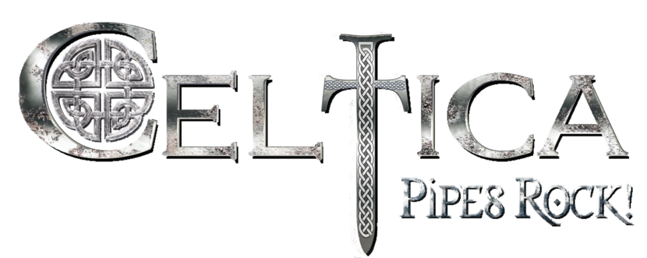
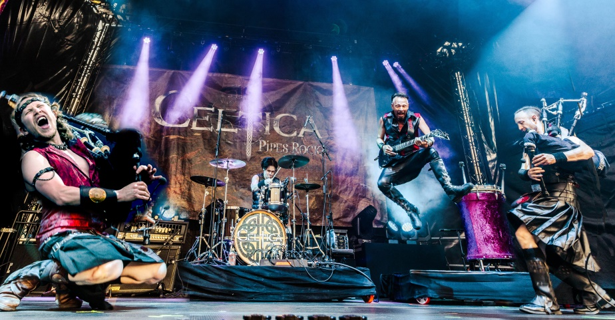

Celtica is one of the most innovative and creative bands in Folk- and Celtic-Rock, they fascinate audiences from metalheads to grandmothers all across the world. More than 550 performances from Alaska to Hawaii, from Wacken to India, winner of Australian Celtic Music Awards as „International Artist of the Year 2019“, 5 Studio-albums, 2 live-double-CDs and DVDs with classical orchestra and huge choir are the impressive references of the band. In spite of the Covid-limitations Celtica could present in 2021 for the 1st time live on stage their current album “Celtic Spirits”. Without any doubt it is the best Celtica-album ever, with the mighty symphonic sound Celtica is famous for but also with more Celtic-Irish influences so it sounds brighter and more optimistic as the previous studio album “Steamphonia”. A clear improvement is the newest member of the band, Ernesto Góngora, one of the best bagpipers and whistle-players worldwide, winner of the All Ireland Bagpipe Solo Competition 2019.

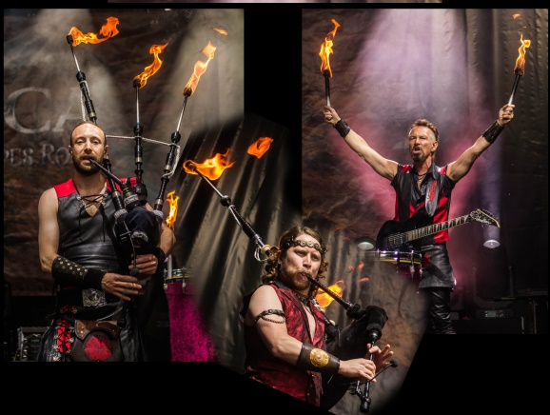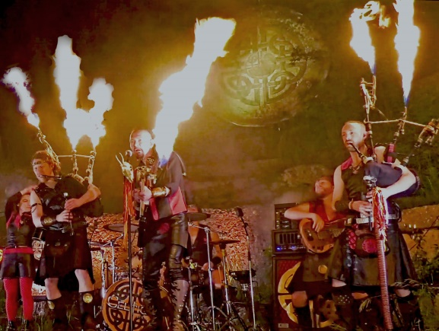
The Sound, the Show

The majestic-mystic sound of the Great Highland Bagpipe elevates above the powerful rock band, influences of Irish Folk, Symphonic Metal, and even Gothic merge with the energetic Celtic music, full of lust of life. This sound and the spectacular show guarantee a concert no one will ever forget. Mystic torches on the bagpipes and burning drumsticks, thundering against huge drums, create a cultic atmosphere, flames, shooting out of the instruments, entertain every audience worldwide…
That´s why Celtica is one of the most booked acts at Celtic-, Scottish-, Steampunk- and Medieval Festivals as well as at town festivals.

Facts
- over 40 official videos, filmed on Hawaii, in NYC, Wacken, Mumbai,...;
- YouTube: over 37 000 Subscribers and roughly 12 Mio views, 450.000 hours playing time
- Spotify: 140.000 listeners, 26 000 listeners monthly,1,2 Mio. streams

„CELTICA is one of the best 10 Live-Shows I have ever seen in my life!“. Suzanne Lee Barnes, Booking European Harley Davidson Bike Week, friends with Eric Clapton, Ron Wood, Rod Steward...
„Celtica is THE new band on the international Celtic music scene!“ Gall Mc Clellan, US promoter
About “Celtic Spirits”:
“Compliments for your new album „Celtic Spirits“! FANTASTIC !!!”, Andrea Poli, promoter, Italy
“This Album is incredible!! What a work! The level of musicians is extraordinary, I haven't listened to an album of this quality for a long time!”Djamel O'TOUIL, Directeur Artistique du "Festival Roches Celtiques"
“The Celtic Rock-album of the year!”, Rick Field, Promoter, Germany

About „Celtic Spirits at Merkenstein“:
„..a top notch audio-visual sensation!“ (DVD) Musikreviews.de
„This album is really brilliant!!“ (CD) HeavyMetal.de
„The quality of the performance is spectacular…I hope that other bands take similar paths and with the same quality to be able to continue listening to great releases like “Live at Montelago!” Folk-Metal, Netherlands

Duncan Knight, Scotland – Great Highland Bagpipe, Vocals
Ernesto Góngora, Mexico– Great Highland Bagpipe, Flute, Whistle
Gajus Stappen, Austria – E-Guitar, Toms, Vocals
Lukas Schlintl, Austria – Drums
www.celticarocks.com
www.facebook.com/Celticarocks
www.youtube.com/channel/UCF7BzOyIfwBZir14Mt-frmw
@celticapipesrock.official • Instagram-Fotos und -Videos

Releases:
Celtic Spirits at Merkenstein, DVD 2021
Celtic Spirits at Merkenstein, Double CD 2021
Celtic Spirits, CD 2020
Live at Montelago, DVD 2018
Live at Montelago, Double CD 2017
Steamphonia, CD 2016
Legends and Visions, CD 2014
Oceans of Fire, CD 2012
Rising, CD 2010
BOOKING
Gajus Stappen +43/699/ 18 58 80 80
info@celticarocks.com

